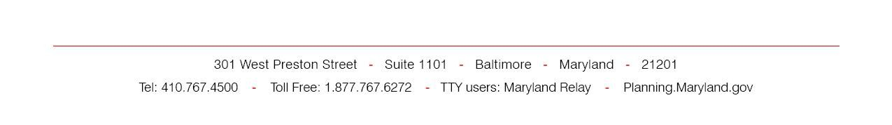



**REAL PROPERTY REPORT**

All information must be completed for declarations of excess real property, and proposed easements. If information is unknown, enter N/A for "Not Appropriate."

|  |  |
| --- | --- |
| *State Application Identifier* | *MMC# (for MDOT’s projects only):* |
| *Project Description* | |

# *Contact Person of Administering Agency*

*Applicant/ Agency*

*Contact Person*

1. ***Description*** (of the Proposed Change, Location, Size, and Physical Characteristics)

|  |  |  |
| --- | --- | --- |
| *County* | *Tax Map#* | *Parcel#* |
| *Grid#* | *Block#* | *Date of availability* |
| Tax map #, Parcel #, Grid #, and Block #" can be found at SDAT's web site: [sdat.resiusa.org/RealProperty/Pages/default.aspx](http://sdat.resiusa.org/RealProperty/Pages/default.aspx) | | |
| *Address* (enter the actual street number, street name, and zip code of the property OR the closest actual street number, street name, and zip code if the property is landlocked or part of a larger tract of land like a rail corridor. In the latter case, you may consider using the address of the closest public facility. Zip codes can be found at U.S. Postal Service’s web  site: <https://tools.usps.com/go/ZipLookupAction!input.action>) | | |
| *Physical Description* (including acreage; indicate if the property is flat, hilly, grassy, barren, forested, other) | | |
| *Certified Priority Funding Area (PFA:* Verify if the site is located in a PFA. Use MDP’s interactive  map, [planning.maryland.gov/OurProducts/iMaps.shtml](http://planning.maryland.gov/OurProducts/iMaps.shtml) by entering the actual street number, street name, and zip code of the property) | | |

REAL PROPERTY REPORT – Page 2

1. ***Current use*** (farm land, open space, office, other)
2. ***Access*** (name of road, highway, Route #, landlocked)
3. ***Building Characteristics*** (list improvements on the land; Structures, if any: the number of buildings; name of each building; its physical condition, and its potential use)
4. ***Environmental issues*** (habitat of species, floodplains, steep slopes, wetlands, other)
5. ***Expressed Interest*** (for both declarations of excess real property, and proposed easements. In addition, for declarations of excess real property, please expand your answer to indicate: contemplated use of the property; whether funds are currently available for acquisition of the property- if not, the time period required to obtain funds if applicable; the name of the grantee to appear on the deed of conveyance)

# *Conditions of Transfer, if any*

1. ***Utilities available*** (Specify public water, public sewer, electricity)

